Lab 13 – Full Wave Rectifier and Biased Transistor

Task 1

*Using PSPICE design a full wave rectifier*

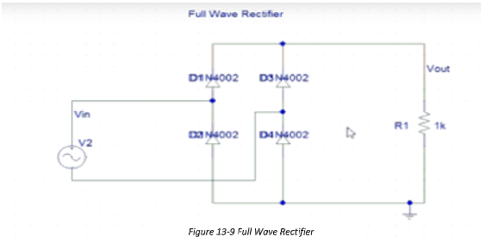

Circuit in PSpice

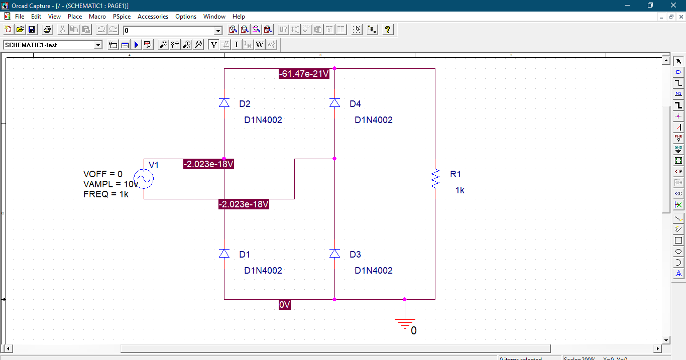

Output: